Apple Samosa
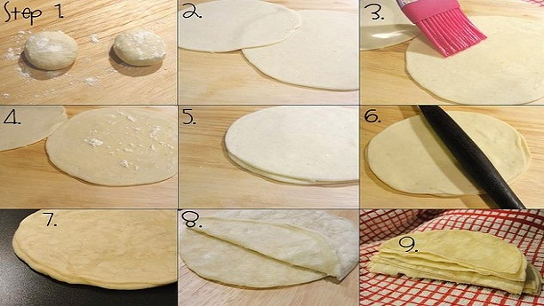
Samosa Flour Sheets:
Ingredients:
- Flour (All-purpose flour, Maida) 250 g
- Salt ½ Tsp
- Lukewarm Water just to make dough
- Vegetable Oil ½ Cup
Recipe:
Mix flour, salt and water in dough making machine or mix it by hand to make the dough.
After making the dough, cover it with a sheet and leave it for half an hour.
After half an hour, make small balls of dough.
Then make flour sheets with these balls and stack it over one another.
Make sure grease each sheet with oil and coat with dry flour dust.
Then cook it over the stove in a saucepan one after another side and separate each sheet.
Samosa Filling:
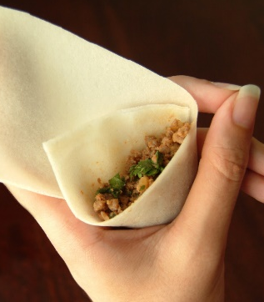
Ingredients:
- Apple (Peeled and cut into small pieces) 500 g
- Potato (Boiled, Peeled and Mashed) 250 g
- Green Onions 3-4 chopped
- Serrano Green Pepper 3-4
- Coriander Fresh leaves a bunch or according to taste
- Salt According to taste
Recipe:
- Mix all the above ingredients in a big bowl and mash it well to form a filling
- Take one flour sheet (prepared above) cut it into two halves with a knife.
- Place some filling mixture over the one half of flour sheet and wrap over, it in the form of a triangle.
- Make all the samosas using the same procedure.
- Note: You can freeze it and fry it fresh whenever you want to take.
- The filling can be made with ingredients of your choice like chicken and ground beef etc.

Apple Pakora
Ingredients:
- 2 cups (250g / 8.8 oz) Besan (also known as Chickpea Flour or Gram Flour)
- 1 tablespoon crushed red pepper flakes
- ¾ teaspoon salt
- 1 green chili pepper, sliced
- ½ cup Cilantro leaves, chopped
- Spinach leaves, chopped (size and amount vary according to desire)
- 1 Apple, chopped according to desire
- 1 Potato, chopped according to desire
- 1 yellow onion, sliced into 1/8-inch half moons
- 1 cup luke-warm water
- Sunflower oil (or any neutral oil like vegetable, safflower, canola, etc.), for deep frying
Preparation:
- In a large bowl, mix together the besan, red chili flakes, salt, baking powder, sliced chili pepper, cilantro, chopped apple and potato and sliced onion.
- Slowly add in the water, while mixing with a wooden spoon or your hands. Vigorously mix for a couple of seconds
- Fill an 8-inch cast-iron skillet half-way up with oil. Heat the oil to 360-375ºF.
- Once the oil is heated, carefully place in a heaping tablespoon full of batter into the hot oil.
- Try not to overcrowd the oil because it will result in greasy pakoras.
- Fry until the pakoras are a pecan-brown. Drain on a cooling rack placed over a cookie sheet.
- Repeat with the remainder of the batter.
- Serve right away, and enjoy hot apple pakoras.

